The Language Feat Prize
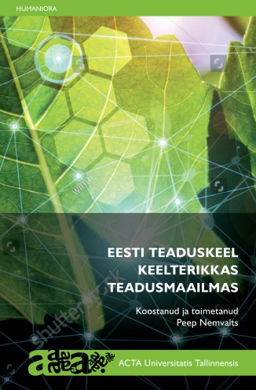
Since 1996, Estonia has celebrated Mother Tongue Day on March 14th. This was the birthday of the first Estonian poet Kristian Jaak Peterson in 1801 (d. 1822). Language Feat Prizes for the previous year have been awarded around this day for 14 years. The nominees are picked by the Board of the Mother Tongue Society among the candidates presented by people. This year, a record 35 nominees were proposed for the jury for the Grand Prize and for public voting for People’s Prize. The Language Feat Grand Prize 2020 was awarded by the jury consisting of all ministers of education and research of the Republic of Estonia to the book Eesti teaduskeel keelterikkas teadusmaailmas (“Academic Estonian in the multilingual world of science”, 270 pp., ISBN 978-9985-58-888-8), compiled & edited by Peep Nemvalts, published by Tallinn University Press 2020. The book includes nine articles written in Estonian by researchers of various disciplines from several universities, English summaries, as well as preface and a short list of the most central Estonian terms of academic language and terminology with concept definitions. The contributors are
- Peeter Saari, Doctor of Sciences in Physics and Mathematics, Professor of Wave Optics at the University of Tartu and board member of the Estonian Academy of Sciences: “The National Language of Science from the Viewpoint of a Physicist”.
- Kaarina Rein, PhD in classical philology from the University of Tartu: “Rendering Early Modern Medical and Alchemical Vocabulary in Estonian Texts”.
- Gerhard Lock, a native German composer, musician and Lecturer of Musicology and Multimedia at Tallinn University: “The New and the Old as music history categories”.
- Helena Sepp, a Finnish PhD student of history from Turku University (Finland): “A Linguistic Commentary on the Theses Written in Estonian at Tallinn University 2003 – 2017 - The Supervisor’s Perspective”.
- Tiiu Kuurme, Associate Professor of Educational Sciences at Tallinn University: “The language we use to speak about education”.
- Peep Nemvalts, Head of the Centre for Academic Estonian at Tallinn University, senior research fellow: “Estonian terms designating the concept system of ’nation’”.
- Sulev Kuuse, Head of the Laboratory of the Animal Facility at the Institute of Molecular and Cell Biology, and Toivo Maimets, Professor of Cell Biology and Director of the Institute of Molecular and Cell Biology, University of Tartu: “Who needs a textbook of Cell Biology in the Estonian language?”.
- Jakob Kübarsepp, Professor of Materials Engineering at Tallinn University of Technology, Fellow of the Estonian Academy of Sciences, and Priit Kulu, Professor Emeritus of Metals Science: “Estonian scientific language in engineering”.
- Maret Nukke, Lecturer of Japanese Studies at Tallinn University: “Nominalization and Other Condensing Devices of Text: Opportunities and restrictions in Japanese academic texts derived from the Japanese writing system”, incl. some comparisons with academic Estonian.

